Positive Test Cases :-

FeatureSet Variation 1 :

FeasureSet Implementation Details

a) All accident information collected from various sources using text mining b) events causing the accidents c) the nature of the accident, causal agents d) location of the accident e) vehicle involved in the accident f) time of the accident.

Sentence, Verb, SRL Cause, Nom, Nominal Cause, Location, Vehicle, Temporal

Sentence From Corpus : Luis Aleman-Mendoza, 18, killed and two people injured in four-vehicle car wreck on Interstate 35E in Lewisville, Texas .

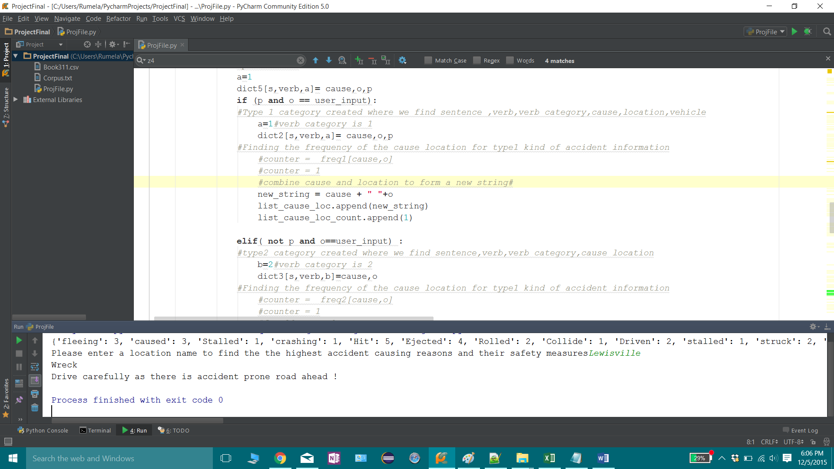

FeatureSet Variation 2 :

b) All accident information collected from various sources using text mining b) events causing the accidents c) the nature of the accident, causal agents d) location of the accident e) vehicle involved in the accident

FeasureSet Implementation Details

Sentence, Verb, SRL Cause, Nom, Nominal Cause, Location, Vehicle

Sentence from corpus : Thomas Aring, 64, killed and two people injured in multi-vehicle crash at Farm to Market Road 423 and Main Street in Frisco, Texas .

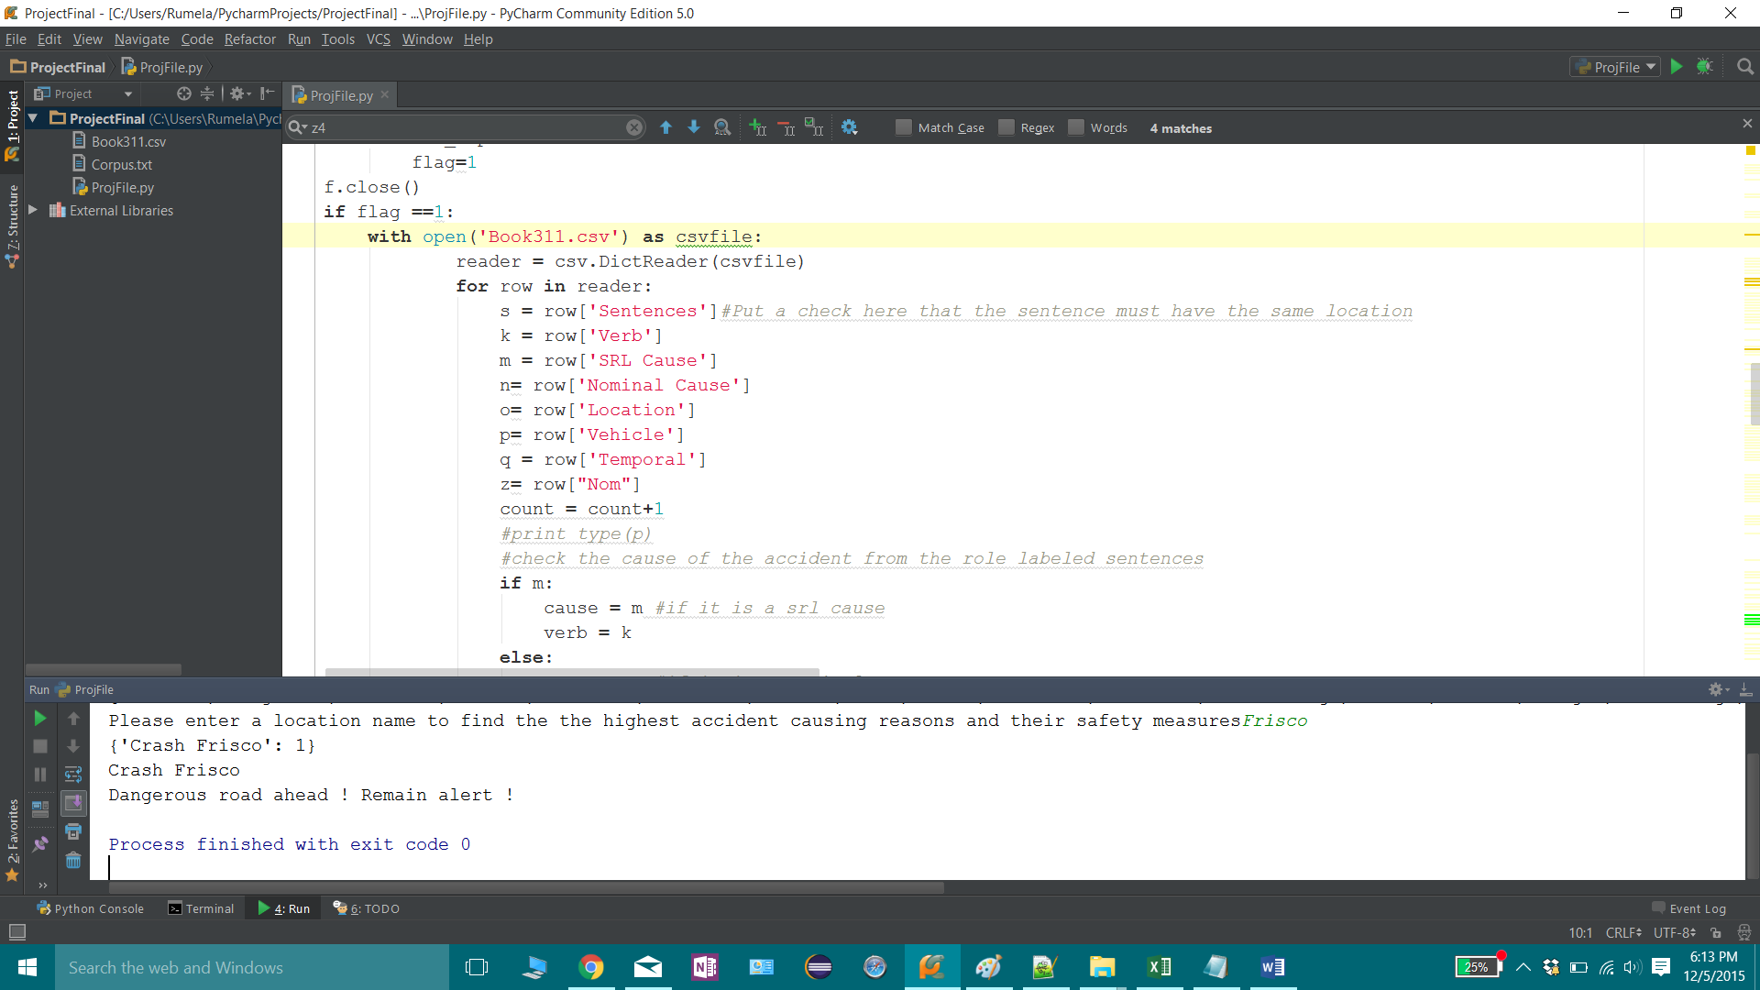

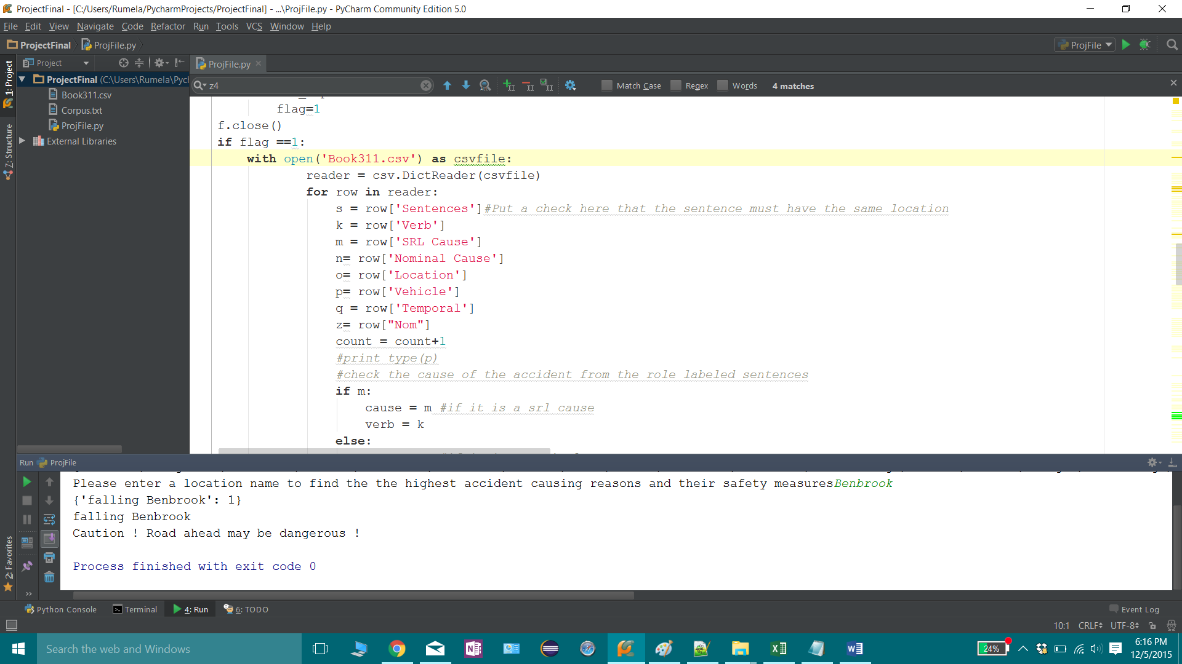

FeatureSet Variation 3 :

c) Location, Cause Unknown

Sentence, Location

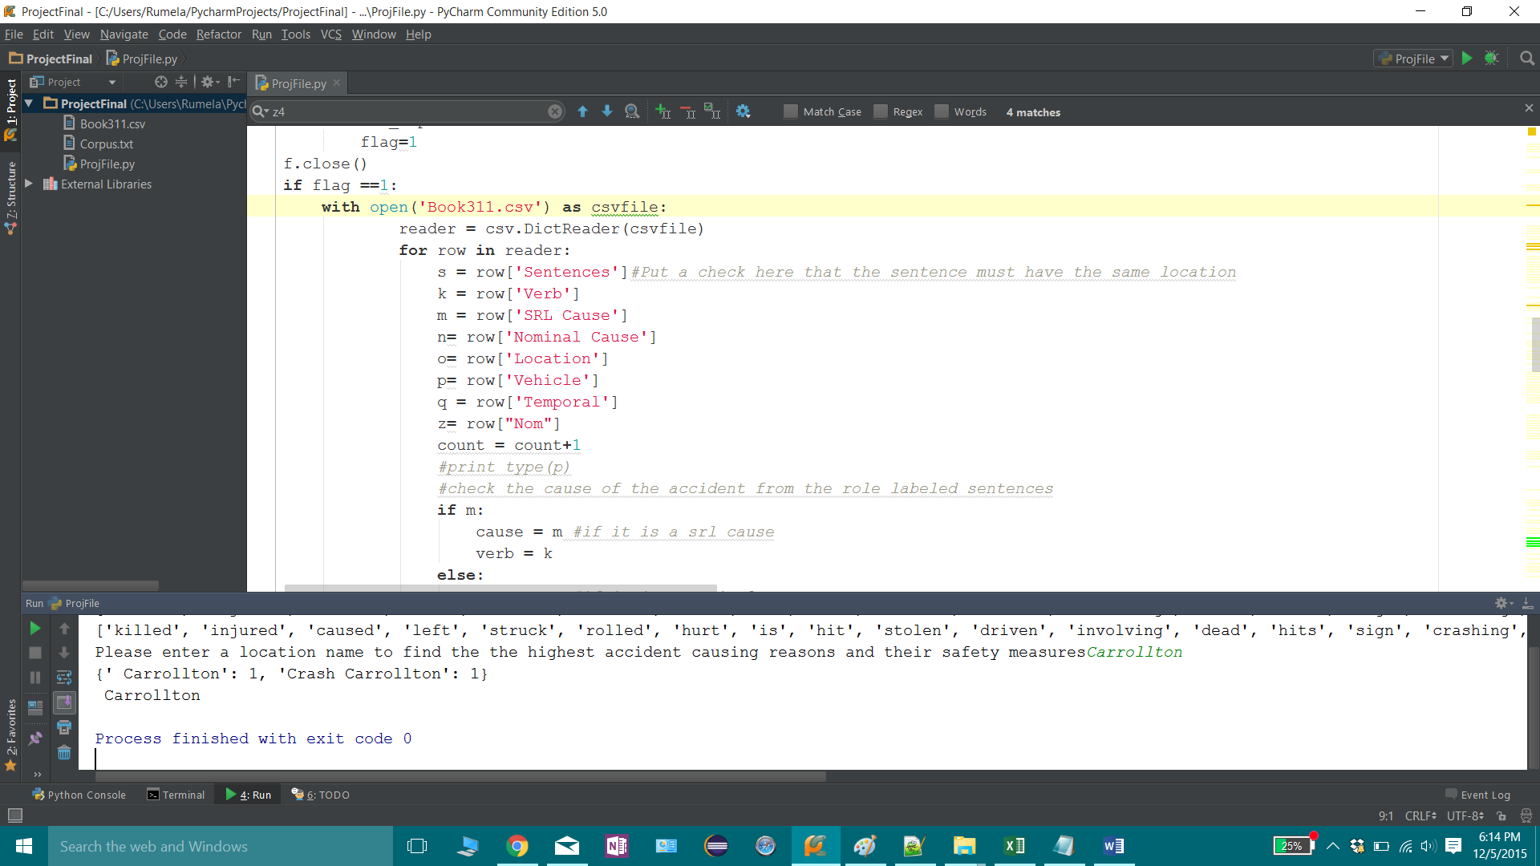

Negative Test Cases :

1. Paris is not in corpus , so it is not in analysed file. Hence the case :

The location will be surveyed and updated soon for accident prediction!!Thank you for your patience!!

The accident at this location does not have sufficient information!!

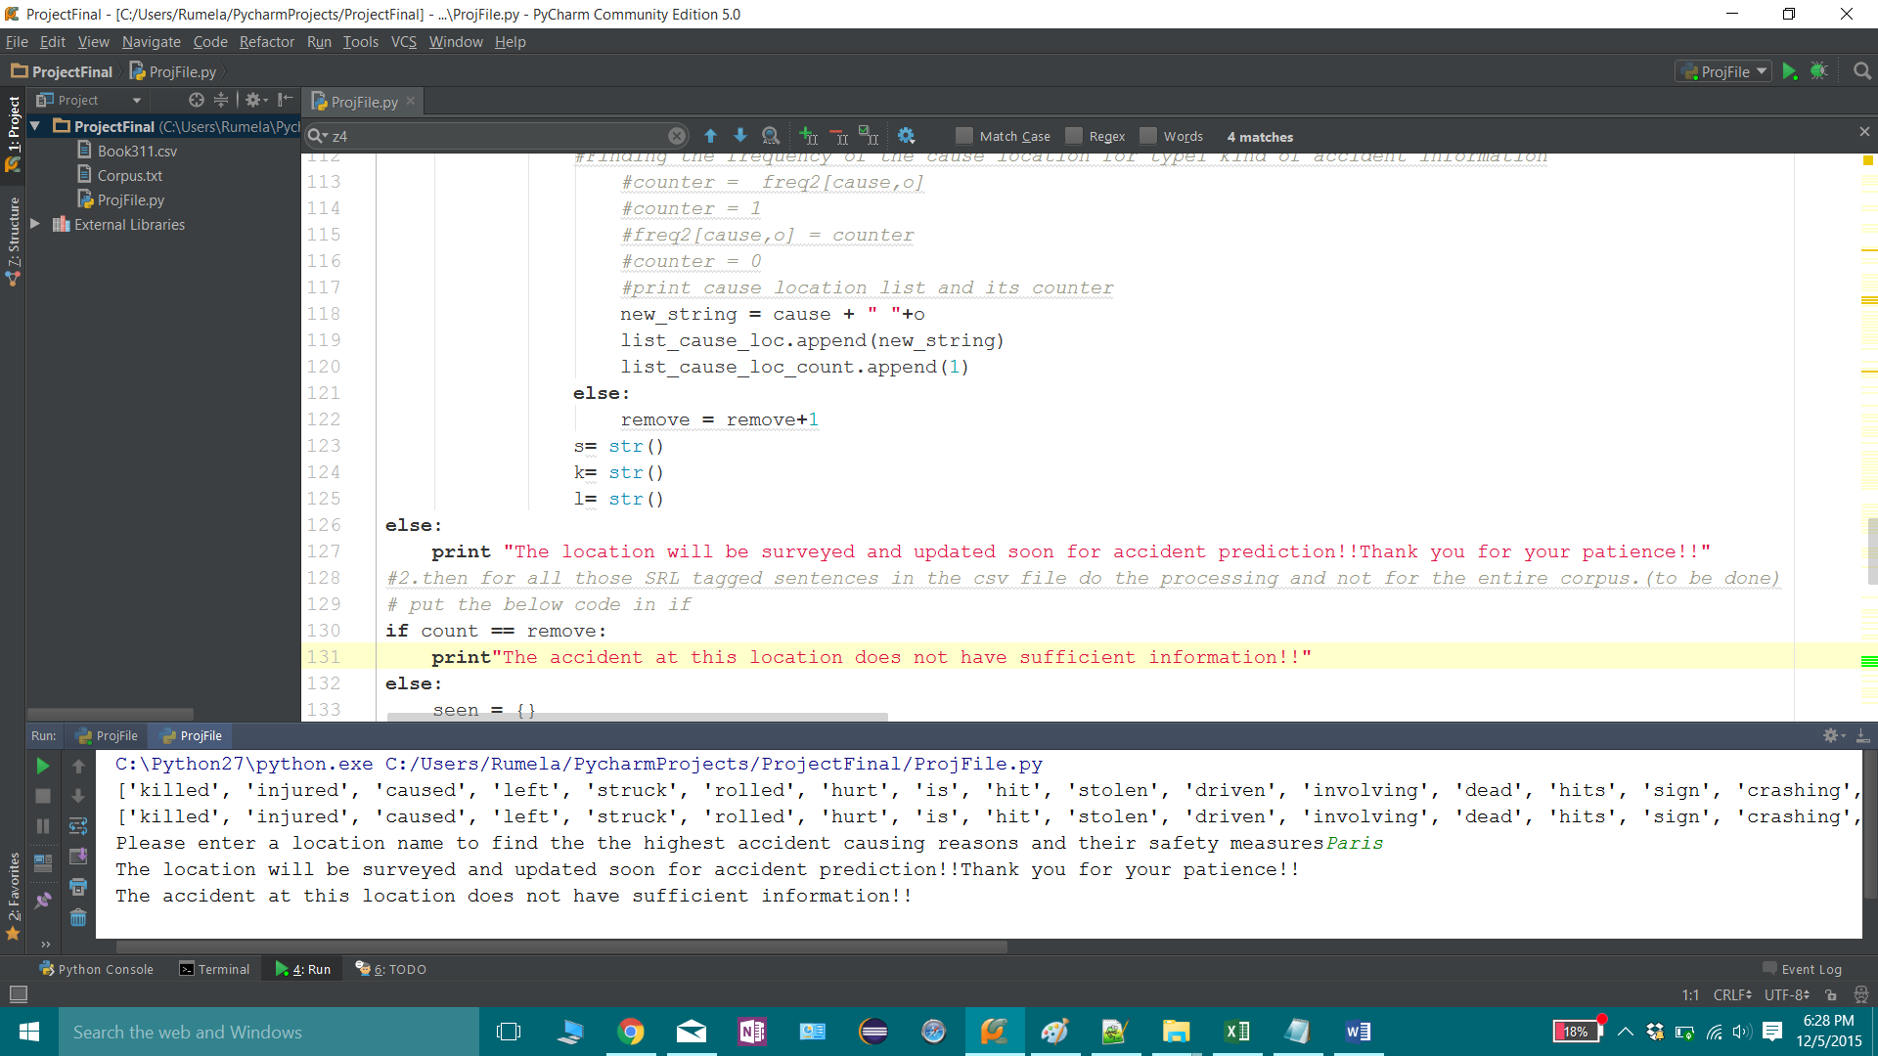

1. Saginaw is present in corpus but the accident information does not have relevant featureset.

Sentence in Corpus : Vincent Ireland, 17, killed and another teen injured in violent car crash on East McLeroy in Saginaw, Texas

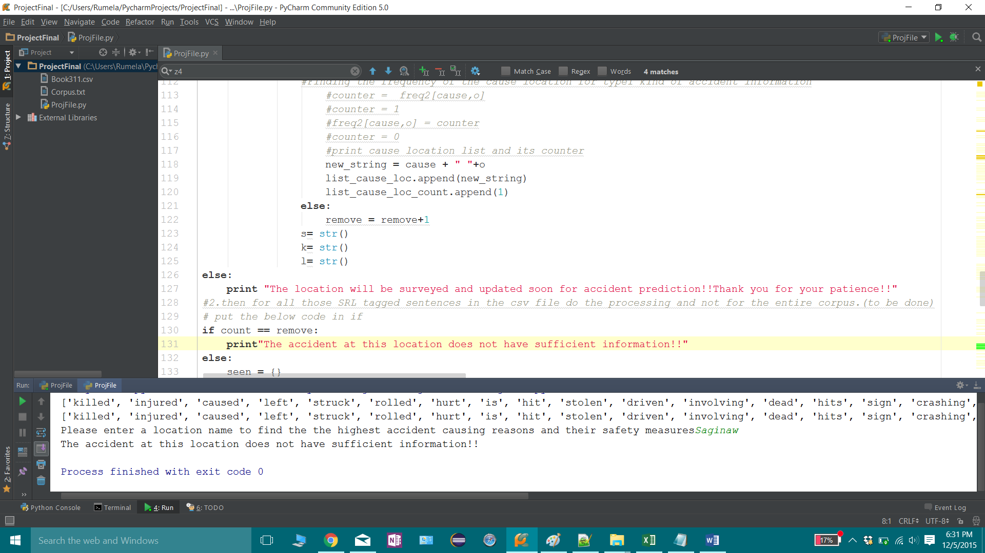

1. Not SRL tagged but present in the corpus – Unstructured Sentence

Sentence in Corpus : Stacey Daily, 40, and Jessica Lee Harris, 34, killed, and several injured in head-on car collision with church van on Texas Highway 377 near Mineral Wells, Texas

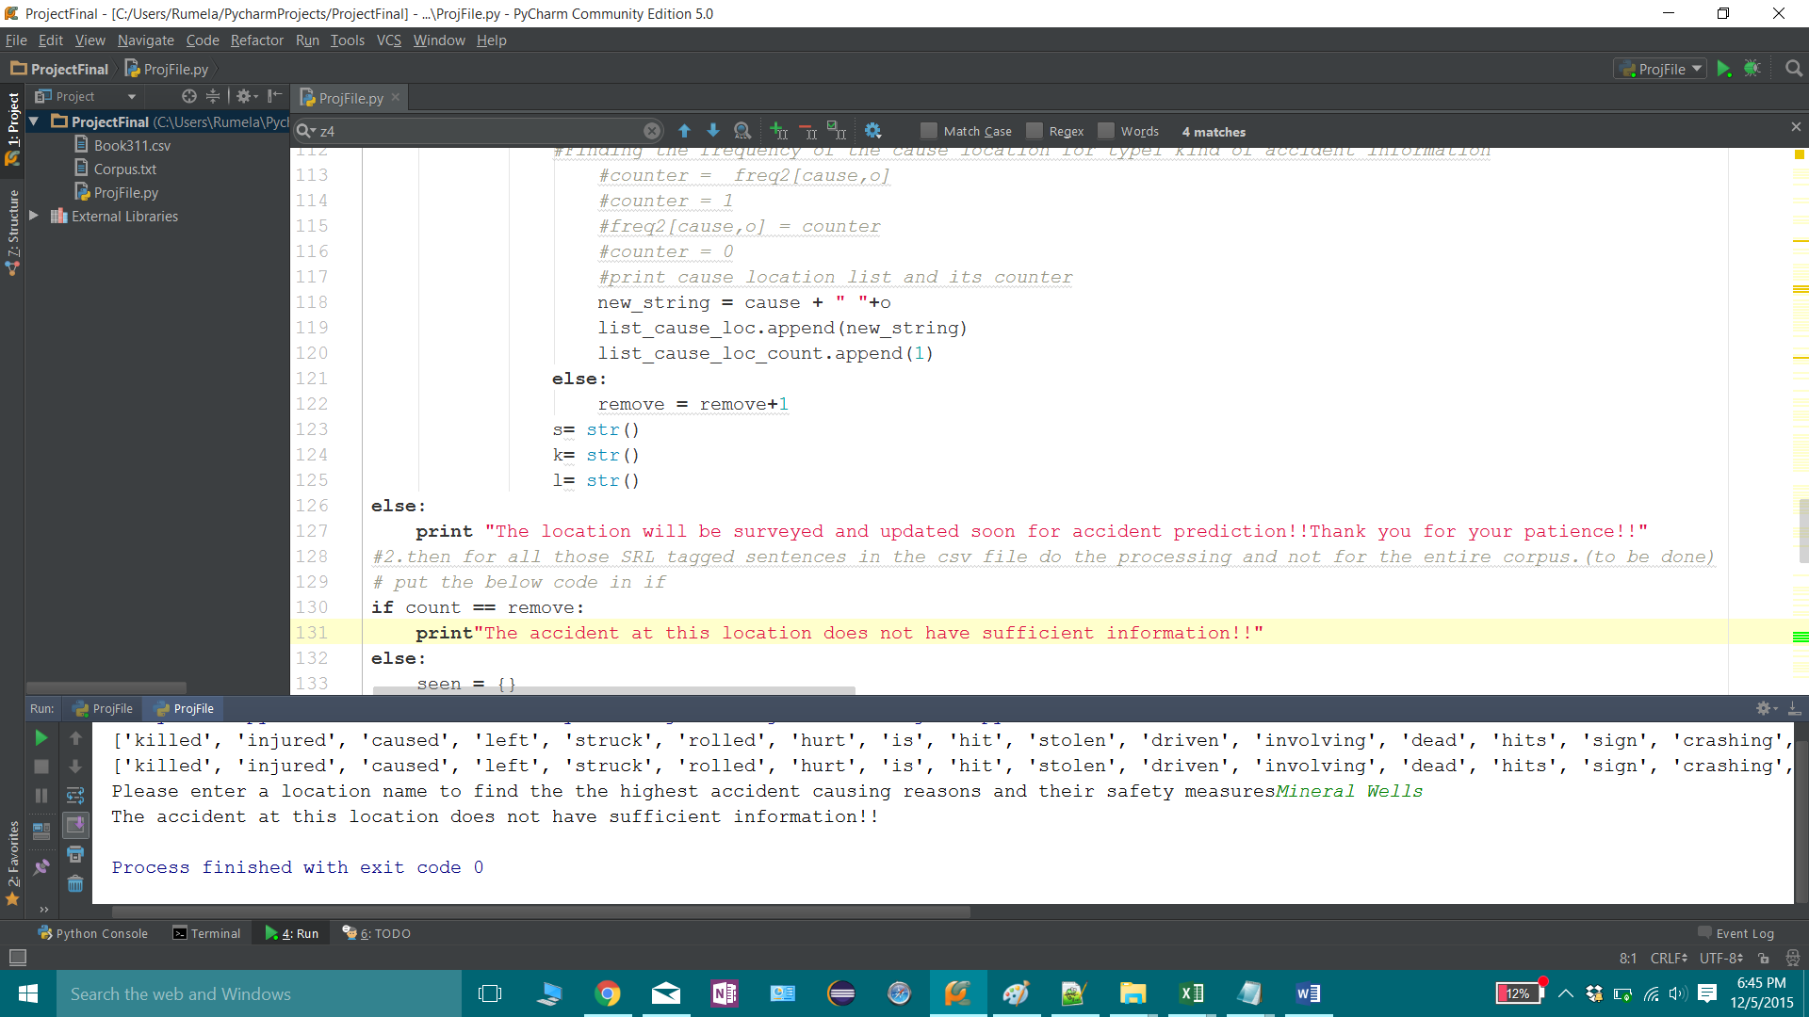

1. Syntactically and semantically correct , so can be SRL tagged but when mapped to the featureset, does not return any value.

Sentence in Corpus : Ricky Joe Katcher, 51, dies after falling from an overpass after a car accident on Interstate 20 near Benbrook, Texas .

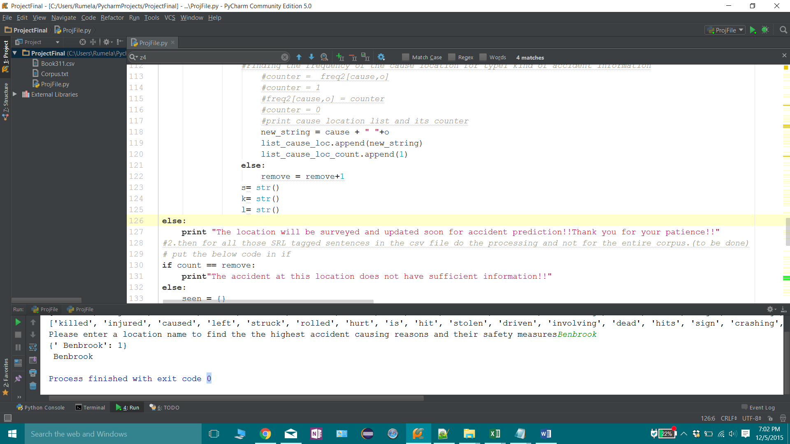

Type 2 negative test case : Syntactically and semantically correct SRL tagged sentence not having vehicle and temporal but still does not give correct output.

Sentence in Corpus : Five people injured in road-rage related crash at South Lancaster Road and Motor City Boulevard in Dallas, Texas .

